

Mariner: 220x46 OSV
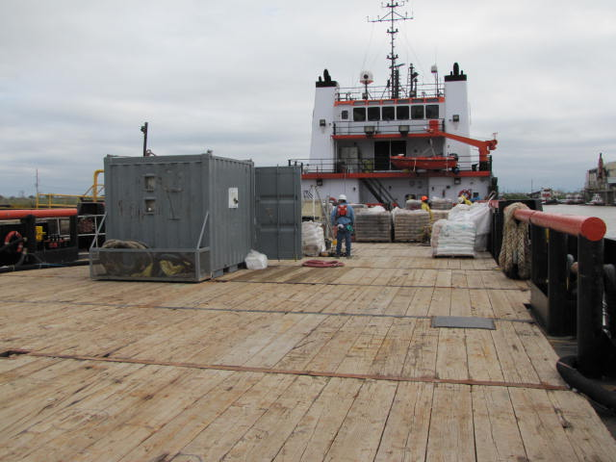

SPECIFICATIONS: CAPACITIES:
Length: 220’ Deadweight: 1,600 LT
Beam: 46’
Draft Max: 13’ 8” Deck Cargo: 1,030 LT
Brine: 3,000 bbl
Draft Min: 8’ – 11’ Liquid Mud: 3,000 bbl
Certifications: Oceans, SIP Potable Water: 28000 gallons
USCG Subchapter I, USCG Subchapter L Rig Fuel: 110,000 gallons
Classifications: ABS Loadline valid until January 5, 2017 Rig Water: 100,000 gallons
Built 1999 2000

MACHINERY: ACCOMMODATIONS:
Main Engines: (2) EMD 12-645-E2 10 air conditioned/heated staterooms
Propellers: FPP, 4-Blade Propeller certified for 22 person berthing
Generators: (2) Cummins NT855; 250 kW
Bow Thruster: (1) SMI FPP Tunnel; 755 hp
Stern Thruster: (1) SMI FPP Tunnel; 525 hp
Rudder: Independent Steering, Spade Type
Power Generation: 480V/60 Hz/3-Phase

ELECTRONICS:
Auto Pilot, Beier IVCS 2000, C-Nav, CCTV Cameras, Depth Sounder, DGPS, EPIRB, Fanbeam, GMDSS "A3", Gyro Compass, Joystick Control, Loudhailer, Mag Compass, MAMS/VMS, Navtex, Radar (S-band), SARTs, VHF Radio, VHF Radio (Handheld), Windbird, X-band Radar
DP ABS Loadline

(All details and specifications as per Owner and not guaranteed by Broker.)

